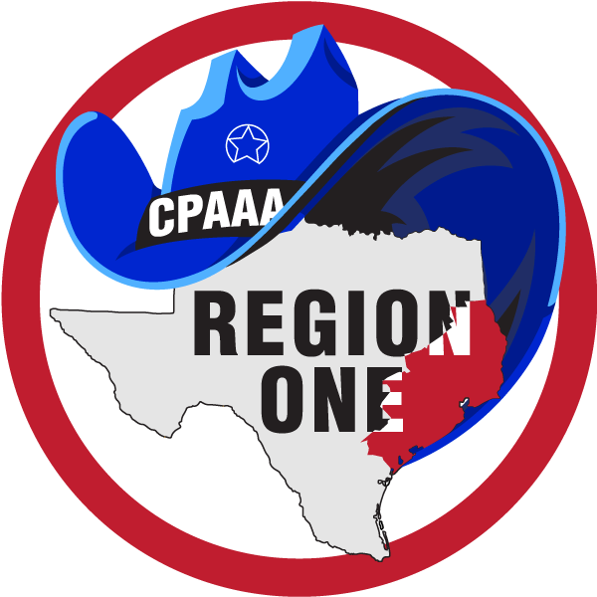
LAW ENFORCEMENT CAREER SCHOLARSHIP APPLICATION

REGION ONE - TEXAS CITIZEN POLICE ACADEMY ALUMNI ASSOCIATION
A 501C3 NON-PROFIT ORGANIZATION

SCHOLARSHIP Select one:
______ Law Enforcement
______ Civilian
QUALIFIED APPLICANTS:
Applicants must be one of these FIVE:
(1) An alumni member
(2) Family member of Region One Alumni include children and grandchildren
(3) A law enforcement officer
(4) Officer's family member
(5) Must be a resident of Region One
The Texas Citizen Police Academy Alumni Association Region One, is composed of CPA Alumni Associations in the following counties of the Upper Texas Gulf Coast Region, but not limited to: Angelina, Austin, Brazoria, Brazos, Calhoun, Chambers, Colorado, Fayette, Fort Bend, Galveston, Grimes, Hardin, Harris,Jackson, Jasper, Jefferson, Liberty, Matagorda, Montgomery, Nacogdoches, Newton, Orange, Polk, Sabine, San Augustine, San Jacinto, Shelby, Trinity, Tyler, Victoria, Walker, Waller, Washington, and Wharton.
THE SCHOLARSHIP FUND IS FOR THE QUALIFIED APPLICANT IN THE FURTHERANCE OF THEIR EDUCATION IN THE CRIMINAL JUSTICE FIELD

Confidential Information

Name: _________________________________________ Nickname:__________________

Residential Address: __________________________________________________________

Mailing Address: _____________________________________________________________

email address preferred: ______________________________________________________

Cell Phone # _______________________________________________________________

Date of Birth: _________________________________

Please list the qualification and how related to Region One and/or agency:

__________________________________________________________________________________

__________________________________________________________________________________

High School(s) Attended: _____________________________________________________________

College Attended: Y N ________________________________________________________

Page Two Law Enforcement/Civilian Scholarship Application

Please share your academic and professional goals:
____________________________________________________________________________

____________________________________________________________________________

____________________________________________________________________________

____________________________________________________________________________

Please share any academic honors, awards, school activity participation,
______________________________________________________________________________________________________________________________________________________________________________________________________________________________________________________________________________
__________________________________________________________________________________________
Please share your outside interests and/or other community involvement:
______________________________________________________________________________________________________________________________________________________________________________________________________________________________________________________________________________
Applicant must submit the following:
1. Completed TCPAAA Region One Scholarship Application Form
2. Letter of acceptance from college, university or regional law enforcement academy (or college transcripts if already enrolled and attending)
3. Two letters of recommendation (one can be from an instructor)
4. High school transcript (2.5 GPA minimum)
5. College transcripts (if applicable) (2.8 GPA minimum)
6. An essay of 300-600 words on one of the following topics:
a. Police Community Relations
b. Law Enforcement Role in Society
c. Police Professionalism
d. The Effects of a Law Enforcement Career on Family
e. The Law Enforcement Code of Ethics
7. Please submit Application and all documentation to:
TCPAAA Region One
Scholarship Applications Committee,
1718 Park Avenue, Deer Park, TX 77536

The amount of Law Enforcement Career Scholarship funds to be awarded (not to exceed $500 per scholarship and no more than two recipients per Fall and Spring semesters) will be based on the scholarship fund balance. The Scholarship Committee will make recommendations to the TCPAAA Region One membership for approval. Please note: if you are a high school student currently taking college level courses, you are eligible to apply if you are following a criminal justice career track.
Any questions or concerns please contact: regiononetcpaaa.contact@gmail.com

